PRATEEK GIRISH GIRIRADDI

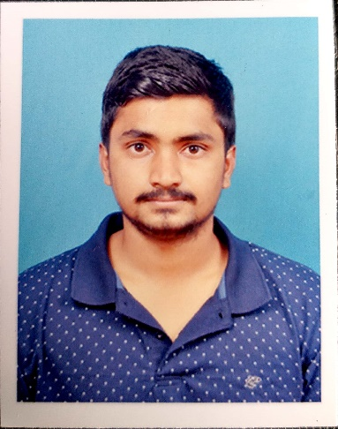

Email: [prateekgg23@gmail.com](mailto:prateekgg23@gmail.com)

Contact number: 6362354841

Objective:

Seeking a challenging career with a progressive organization that provides an opportunity to capitalize my technical skills and abilities in the of information technology.

Education Qualification:

|  |  |  |  |  |
| --- | --- | --- | --- | --- |
| Course | Institute | University | Year of passing | Percentage of marks obtained/CGPA |
| BE in (Civil Engineering) | SDM College of Engineering &Technology | Autonomous College Under VTU, Belagavi | 2022(Pursuing) | 8.0 |
| PUC | VIKAS Pre University Mangalore | Karnataka State Board | 2018 | 84.5% |
| SSLC | Parvathamma Shamanur Shivashankarappa English Medium Residential School, Tholahunse, Davangere | Central Board of Secondary Education | 2016 | 81% |

Academic Projects:

1. Minor Project Report on Intelligent Traffic Monitoring System

This project is aimed at Prioritize moderate traffic conditions by analyzing real-time traffic situations -That is,

-Providing congestion free traffic.

-Improvising traditional ticketing with automated E-Bill payment system.

-Speed sensors to warn commuters over speed violations.

1. Extensive Survey
2. Finding capacity of reservoir

* with using Contour Maps

1. Highway Project

* Finding reduced level with using Profile levelling

Technical skills:

* Auto Cad
* HTML
* Basics of C language
* Excel sheets, Power bi
* Basic skills: MS Word ,MS Power Point & various means communication .

Hobbies:

State level Football player,

Swimmer.

Personal Details:

Father’s Name: Girish v Giriraddi

Mother’s Name: Padma

DOB: 23/09/2000

Languages known: English, Kannada, Hindi, (learning German)

Address: At – Yattinahalli,

Post- Gudagur,

Tal- Ranebennur,

Dist- Haveri,

Pin code- 581115.

Declaration:

I hereby declare that above information is true, correct to the best of my knowledge.